Paper 3 – Geographical applications
Section B – Fieldwork
Fieldwork in 2 contrasting environments –

- River Wyre (physical geography)
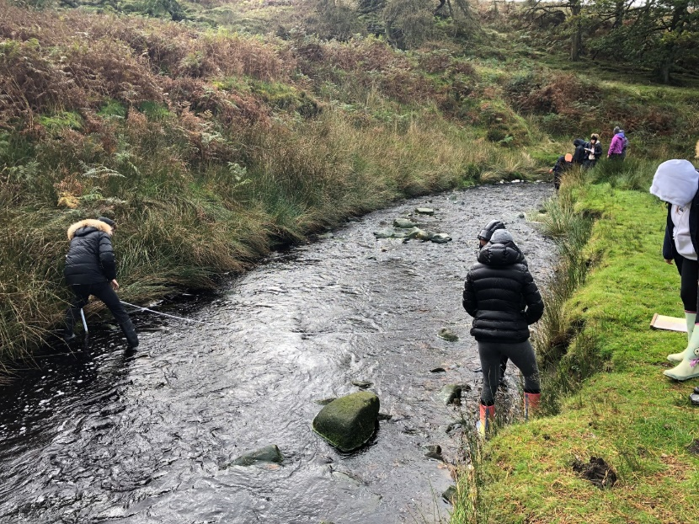

- Liverpool One (human geography)
