Paper 1: Living with the Physical Environment - 22nd May.
1 hour 30 minutes. (88 marks inc. 3 for SPaG, 35% of your GCSE).
Section A – The challenge of natural hazards. You answer all of this section. (33 marks).

Section B – The living world. You answer all of this section. However, you will be asked if you studied a hot desert environment or cold environment, you must state that you have studied hot deserts and answer about hot deserts. (25 marks).

Section C – Physical landscapes in the UK. You answer rivers (Q4) and glaciers (Q5). You DO NOT answer coasts (Q3). (30 marks)

Paper 2: Challenges in the Human Environment – 9th June.
1 hour 30 minutes. (88 marks inc. 3 for SPaG, 35% of your GCSE)
Section A – Urban issues and challenges. You answer all of this section. (33 marks).

Section B – The changing economic world. You answer all of this section. (30 marks).
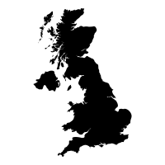

Section C – The challenge of resources management. You answer the challenge of resource management (Q3) and energy (Q6). You DO NOT answer food or water (Q’s 4 & 5). (25 marks).
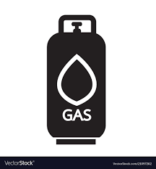

Paper 3: Geographical applications – 16th June.
1 hour 15 minutes. (76 marks inc. 6 for SPaG, 30% of your GCSE)
Section A – Issue evaluation (booklet). You answer all of this section. (37 marks).

Section B – Fieldwork (2 trips). You answer all of this section. (39 marks).
