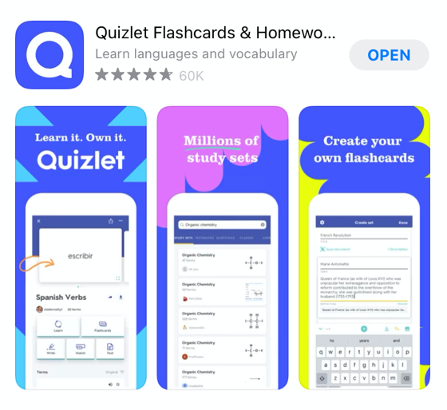
AQA Food Preparation and Nutrition - Quizlet links
Download the ‘Quizlet’ app
These links have a number of different revision activities which you can use including flashcards, test, match, learn.

GCSE AQA Food Preparation and Nutrition - https://quizlet.com/gb/547685841/gcse-aqa-food-nutrition-flash-cards/
Key terms - https://quizlet.com/gb/186912837/aqa-food-preparation-and-nutrition-key-terms-flash-cards/
Vocabulary - https://quizlet.com/gb/247933076/aqa-food-preparation-and-nutrition-vocabulary-flash-cards/

Diet, nutrition and health
- Macronutrients - https://quizlet.com/gb/249073463/macronutrients-flash-cards/
  - Carbohydrates - https://quizlet.com/gb/555791548/nutrients-macronutrients-carbohydrates-flash-cards/
  - Protein - https://quizlet.com/gb/555778183/nutrients-macronutrients-protein-flash-cards/
  - Fat - https://quizlet.com/gb/247932291/aqa-food-preparation-and-nutrition-fat-flash-cards/
- Micronutrients –
  - Vitamins - https://quizlet.com/gb/249181011/vitamins-flash-cards/
  - Minerals - https://quizlet.com/gb/249224004/minerals-flash-cards/
  - Water - https://quizlet.com/gb/640087060/nutrients-micronutrients-water-flash-cards/
  - Minerals - https://quizlet.com/gb/640060751/nutrients-micronutrients-minerals-flash-cards/
  - Retaining vitamins and antioxidants - https://quizlet.com/gb/640055970/nutrients-micronutrients-retaining-vitamins-and-antioxidants-flash-cards/

  - Water soluble vitamins - https://quizlet.com/gb/640025365/nutrients-micronutrients-water-soluble-vitamins-flash-cards/
  - Fat soluble vitamins - https://quizlet.com/gb/640022717/nutrients-micronutrients-fat-soluble-vitamins-flash-cards/
- DRV - https://quizlet.com/gb/249178239/dietary-reference-values-flash-cards/
- Nutritional requirements through life - https://quizlet.com/gb/268282787/nutritional-requirements-through-life-flash-cards/
- Energy needs - https://quizlet.com/gb/268541415/energy-needs-flash-cards/
- Energy needs - https://quizlet.com/gb/556166781/nutritional-needs-and-health-energy-needs-flash-cards/
- Diet nutrition and health - https://quizlet.com/gb/279738525/diet-nutrition-and-health-flash-cards/
- Eatwell Guide - https://quizlet.com/gb/619994457/eatwell-guide-flash-cards/

Food science
- Cooking of food and heat transfer - https://quizlet.com/gb/280073029/cooking-of-food-and-heat-transfer-flash-cards/
- Functional and chemical properties of food - https://quizlet.com/gb/280102839/functional-and-chemical-properties-of-food-flash-cards/
- Functional and chemical properties of food: Carbohydrates https://quizlet.com/gb/556510731/functional-and-chemical-properties-of-food-carbohydrates-flash-cards/
- Functional and chemical properties of food: Protein https://quizlet.com/gb/556505093/functional-and-chemical-properties-of-food-proteins-flash-cards/
- Cooking of food and heat transfer: selecting appropriate cooking methods https://quizlet.com/gb/556207628/cooking-of-food-and-heat-transfer-selecting-appropriate-cooking-methods-flash-cards/
- Cooking of food and heat transfer: Why food is cooked and how heat is transferred to food
https://quizlet.com/gb/556199475/cooking-of-food-and-heat-transfer-why-food-is-cooked-and-how-heat-is-transferred-to-food-flash-cards/

Food safety
- Food safety - https://quizlet.com/gb/247931692/aqa-food-preparation-and-nutrition-food-safety-flash-cards/
- https://quizlet.com/558928533/aqa-gcse-food-preparation-and-nutrition-food-safety-diagram/#
- Food spoilage and contamination - https://quizlet.com/gb/280460076/food-spoilage-and-contamination-flash-cards/
- Buying and storing food - https://quizlet.com/gb/631231255/food-preparation-and-nutrition-term-1-food-safety-buying-and-storing-food-flash-cards/
- Preparing cooking and serving food - https://quizlet.com/hk/618345330/preparing-cooking-and-serving-food-flash-cards/

Food choice
- Food choice- https://quizlet.com/gb/280715595/food-choice-flash-cards/
- British and international cuisine - https://quizlet.com/gb/280871365/british-and-international-cuisines-flash-cards/
- Factors affecting food choice: Food choices
- https://quizlet.com/gb/598335978/factors-affecting-food-choice-food-choices-flash-cards/

Food provenance
- Environmental impact and sustainability: food sources
- https://quizlet.com/gb/604542973/environmental-impact-and-sustainability-food-sources-flash-cards/
- Food provenance - https://quizlet.com/gb/280875911/food-provenance-flash-cards/
- Food processing and production - https://quizlet.com/gb/280879084/food-processing-and-production-flash-cards/
- Examples of seasonal foods - https://quizlet.com/gb/494229055/seasonal-food-flash-cards/
- Carbon footprint - https://quizlet.com/645874861/carbon-footprint-flash-cards/

