Year 8 French
Hi Everyone,
We hope that you and your families are all well and continue to be. We also hope that being off school doesn’t stop your learning, so we have put together a variety of things to keep busy with.
- Ideally, you will look at everything in your red book regularly so that you don’t forget your vocabulary and grammar. Look at everything we have covered so far, but feel free to research some new language learning too – whatever takes your fancy!
- As a special project, we would love you to make a Powerpoint Presentation or Poster about how Spring events such as Saint Valentin, La Chandleur and Mardi – Gras are celebrated in France and French speaking countries. These can also be religious days, so you could research Holy Week and Easter and Easter traditions. Find as many pictures, funny stories, songs and explanations as you can, even in English and send us your project via email d.williams@sbchs.co.uk / e.gallagher@sbchs.co.uk / c.williams@sbchs.co.uk. We will give out extra Class Chart points for this special assignment!
- Visit this website and download a topical worksheet. They cover all kinds of all special cultural days which are celebrated about now and the answers appear at the end of the sheet.
https://www.pearsonschoolsandfecolleges.co.uk/secondary/subjects/modernlanguages/studio-11-14-french-ks3#support-material
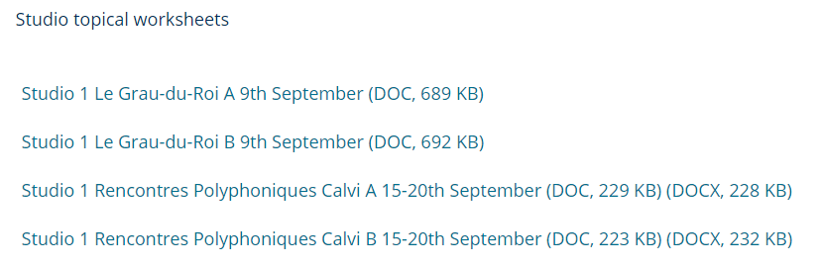

!!Use https://www.wordreference.com as an online dictionary (DO NOT USE GOOGLE TRANSLATE!)!!
- You should also be able to have some fun with your independent language learning, so here is a variety of different websites which you can use for your French learning at home. Use whichever one you find easiest to use and the most effective for you. Please send your teacher a screen shot via email everytime you complete a quiz, win a game, or write a few sentences so we can see how you are getting on. You could also tag us on Instagram @stbedesormskirkmfl – you know we’d love that!
- www.atantot.com
This website is wonderful for playing games! It teaches you the words and then tests you on them in a variety of ways. Click on Key Stage 3 French, and as we have to pay for this website, so it will need you to log on with these details: Username: bede1, Password: 2824
- https://www.memrise.com/courses/english/french/?q=studio+2
You have probably already set up an account for this website, and we would also recommend you to download the app. The link above takes you to our Studio textbook games, but feel free to play any KS3 French games you come across!
- https://www.bbc.co.uk/bitesize/subjects/zgdqxnb
This website has SO much on it! You can practise listening, reading and learn lots of new French. Take a screenshot like the one below whenever you get a quiz right and send them to us or tag us!
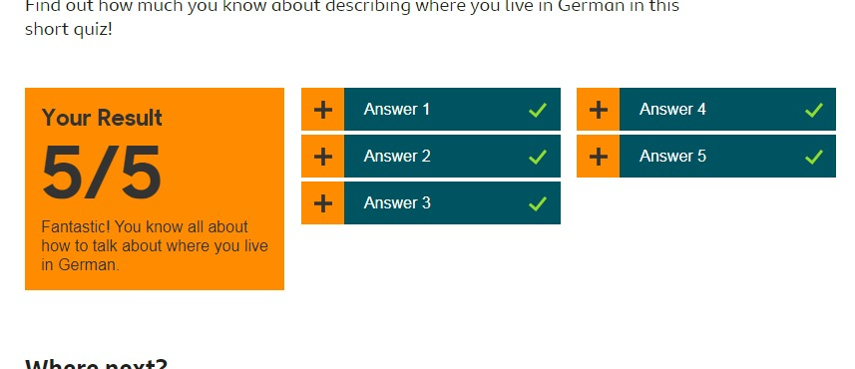
- Another great app to download is Lyrics Training. Its FREE and you can listen to 3 songs every 30 minutes which is more than enough, without paying any subscription.
You can use it to improve your French listening and it uses YouTube songs! You can select different genres, pop, rock, rap even Disney songs! There are all the current top 40 videos in here! If you use the karaoke setting, you can just read the lyrics and listen to the song, but if you select beginner, intermediate or advanced, it removes words of the song and gives you a multiple choice to fill it in again. It's amazing!
- https://quizlet.com/join/RawPZYray
You must be over 13 to sign up to this website and again, it matches our Studio textbook, so have fun playing a few games!

