St Bede’s Catholic High School

Safeguarding Children

Keeping Children Safe in Education (Sept 2021)

We can all play a part in keeping children safe whilst working on or visiting the school site. This is whether you are directly employed by the school, working as a contractor, sub-contractor or a volunteer.

Keeping Ourselves Safe

We must also take steps to keep ourselves safe. Our actions can sometimes be perceived in a way that was not intended. We want to promote safe working practices for everyone on the school site, whatever our role. To keep yourself safe please follow this:

For all adults in school
DO...

- Wear your visitors’ badge at all times.
- Report any unacceptable behaviour from a pupil by ringing main reception on 120 who will contact the SLT on call.
- Be aware that any contact made outside of the school environment as a result of you coming into contact with a pupil whilst you are on a school site, may have an impact on your employment. If you are unsure please ask for advice from our Safeguarding Team.

DO NOT...

- Instigate verbal or physical contact with pupils (this applies both on and off site)
- Respond to verbal or physical contact from pupils. If this occurs, or you have any other concerns about pupil behaviour, then report it to the member of school staff who is working with you.
- Give any personal information to any pupil, for example your name, address, telephone or mobile number, email address or personal websites.
- Accept or respond to a pupil attempting to give you personal information, for example their name, address, telephone or mobile number, email address or personal information.
- Accept physical or verbal abuse from a pupil. DO NOT respond yourself, but report it immediately to a senior member of staff or the reception ext 120 if you do not know who they are or if they are unavailable.
- Make personal comments, judgements or observations about a pupils behaviour, background or family. Never make a comment to a child that you would not make in front of another adult or a member of the child’s family.
- Use your mobile phone, iPod or any other electronic equipment in places where pupils may be present e.g. corridors, classrooms, canteen, playground, reception area etc.
PLEASE FOLLOW THE ADVICE IN THIS LEAFLET AND KEEP YOURSELF AND OUR PUPILS SAFE!

For Visitors
If a child makes a verbal or written disclosure to you...

DON’T...

Promise confidentiality,

Ask leading questions,

Investigate

DO...

Listen

Reassure the child

Tell them you will have to pass on the information to a permanent member of staff at SBCHS

Make a written account in black or blue ink, sign, date and write your full name.

Report your concerns to a member of staff who is working with you. They will report this to the DSL. If in a classroom with a phone ring the main reception on 120 and explain your situation. If there is no phone present escort yourself and pupil to main reception.

Safeguarding Team

Designated Safeguarding Lead (DSL)
Mrs Debra Harris (Assistant Headteacher)

Backup Safeguarding Leads
Mr Philip Denton (Headteacher)

This guide has been produced to help staff and visitors establish the safest possible learning and working environments which safeguard young people and reduce the risk of staff being falsely accused of improper or unprofessional conduct.

All pupils have the right to be treated with respect and dignity.

SBCHS has zero tolerance to aggressive behaviour from pupils, staff, visitors and parents/carers.

For staff :

- Staff should wear identity badges at all times.

- Staff should swipe in the building at the start of the day and swipe out when leaving the premises.

- Safeguarding concerns should be factual and accurate at all times and submitted online or if there is an ICT problem via manual back up system.

- Staff should avoid one to one in areas of school without visibility to other staff – privacy but not isolated.

- Risk assessments should be done by all middle Leaders of areas of risk for staff and pupils.

- All adults working with children must have undergone safeguarding checks.

- All staff should report all incidents even if they think they are minor. It is good practice to share information and the DSL will manage this on the behalf of staff. Early referrals are vital to support children in keeping them safe (KCSIE 2021).

We will always be polite and show respect to you

In return we ask the same from you

We ask that you treat others as you would like to be treated yourself

WE DO NOT TOLERATE FROM MEMBERS OF OUR COMMUNITY:
- Physical Violence
- Verbal Abuse or Threats
- Racial or Sexual Discrimination
- Alcohol or Drug Abuse
- Sexual Violence and/or sexual harassment
- Any form of bullying

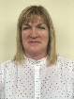
If you require further guidance you can contact Debra Harris on 01695 570335 or d.harris@sbchs.co.uk

Or
Philip Denton on 01695 570335 or p.denton@sbchs.co.uk

Updated 16.11.2021 DHA

ST BEDE’S CATHOLIC HIGH SCHOOL

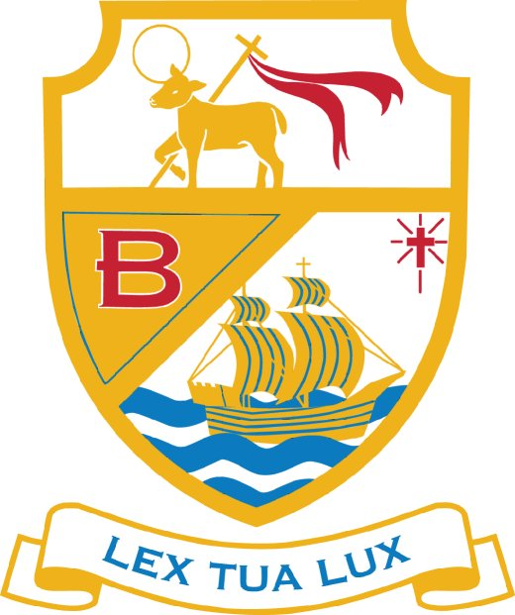

Safeguarding Children

2021

An information and advice leaflet for visitors to school for the protection of everyone

