GRITTY Book Recommendations
Miss Ferries’ Reading Corner
Independence

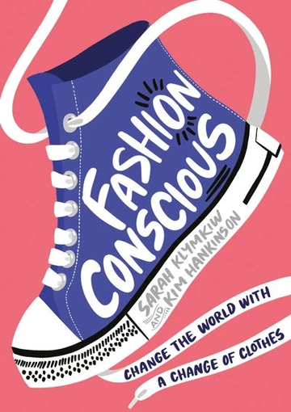
Key Stage Three
‘Fashion Conscious: Change the World with a Change of Clothes’ by Sarah Klymkiw and Kim Hankinson

This book educates young people on sustainability and fashion which helps them to become more informed and independent in their choices of clothing and how to ethically dispose of/ recycle them.

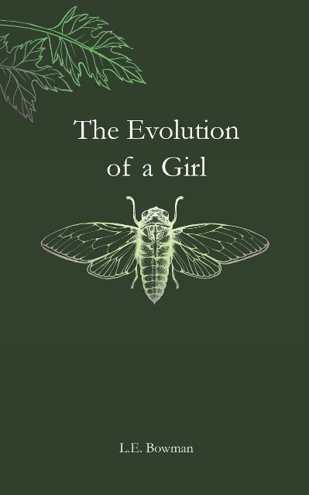
Key Stage Four

‘The Evolution of a Girl’ compiled by L.E Bowman

This beautiful anthology of poetry and prose tracks the journey of being a girl and becoming a woman and the path towards independence and making life choices and embarking upon all the journeys along the way!

