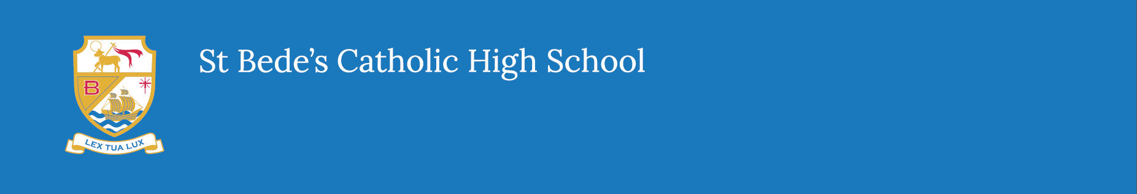
Events 2021/22

Year 11 Guidance Evening | 14th September 2021
Annual Open Evening | 21st September 2021
Year 11 Parents Evening | 30th September 2021
Year 7 Settling In Evening | 14th October 2021
Year 11 Awards Evening | 18th November 2021
Year 11 Mock Exams | 29th Nov-10th Dec 2021
Christmas Carol Service | 13th December 2021
Year 9 Options Evening | 6th January 2022
Year 10 Parents Evening | 24th February 2022
Year 9 Parents Evening | 3rd March 2022
Year 9 Options Form Deadline | 17th March 2022
Year 8 Parents Evening | 21st April 2022
Year 7 Parents Evening | 5th May 2022
Year 11 Leavers Mass | 17th June 2022
Year 10 Mock Exams | 13th – 23rd June 2022
Summer Fair | TBC

