Contextual research on An Inspector Calls
Task 1:
You are going to be completing some contextual research on An Inspector Calls.
This will focus on:
- J. B. Priestley and his life
- Priestley’s views on society
- What was inequality like in 1912 (When the play was set) and how that can be compared to 1945 (When it was performed). This should include gender inequality and class inequality.
- Key events happening in society at both times.
- Key characters – who are they and what is their roles in the play?
- How has Edwardian life influenced Priestley’s work?
- Are there any similarities or differences in comparison to today’s society?

Task 2:
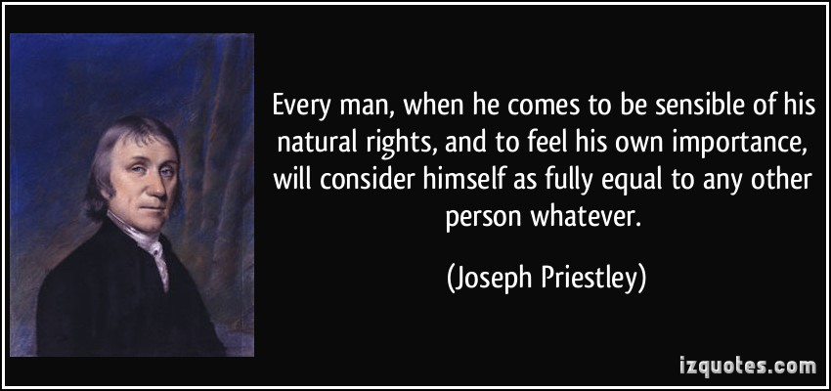
- Why has Priestley chosen to make this statement about equality?
- What does Priestley mean when he describes men as ‘fully equal’?

Task 3:
Choose one of the questions below and write an answer to this using the research you have completed.
- Explain how the context of when the play is set influenced the story. Give at least FOUR reasons.
- “The context of when the play is set (1912) is more important than the context of when it was performed (1945)”.
To what extent do you agree with this statement?

