Blackout poetry:
Blackout poems can be created using the pages of old books or even articles cut from yesterday’s newspaper.
Using the pages of an existing text, blackout poets pick out individual words or short phrases that they piece together to create a poem.
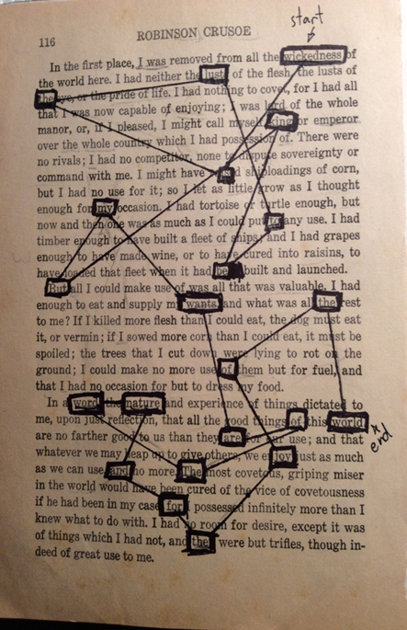
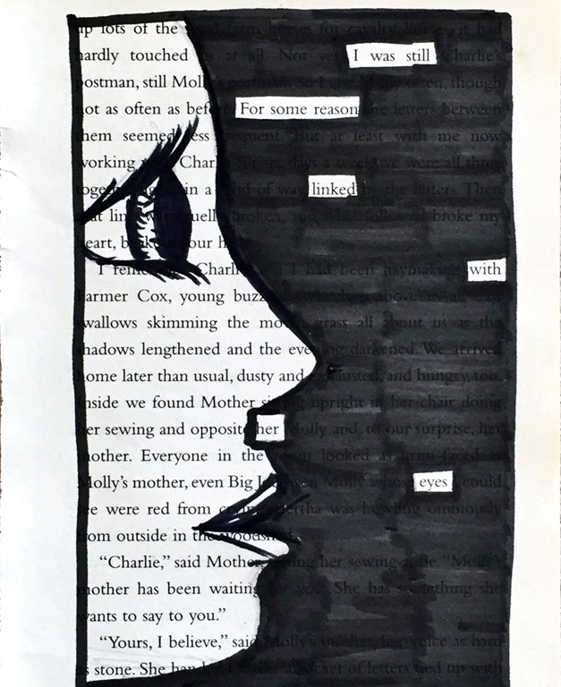
These words or phrases need to work tighter to make sense. The rest of the piece of text is then ‘blacked out’. This is where the creativity happens! Below are some examples of pieces of black out poetry.

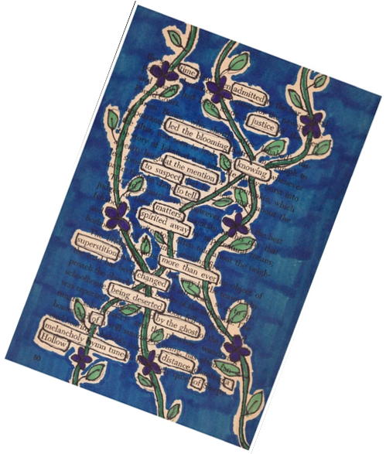
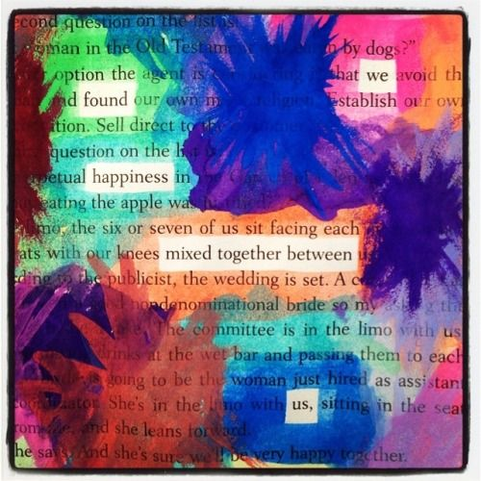
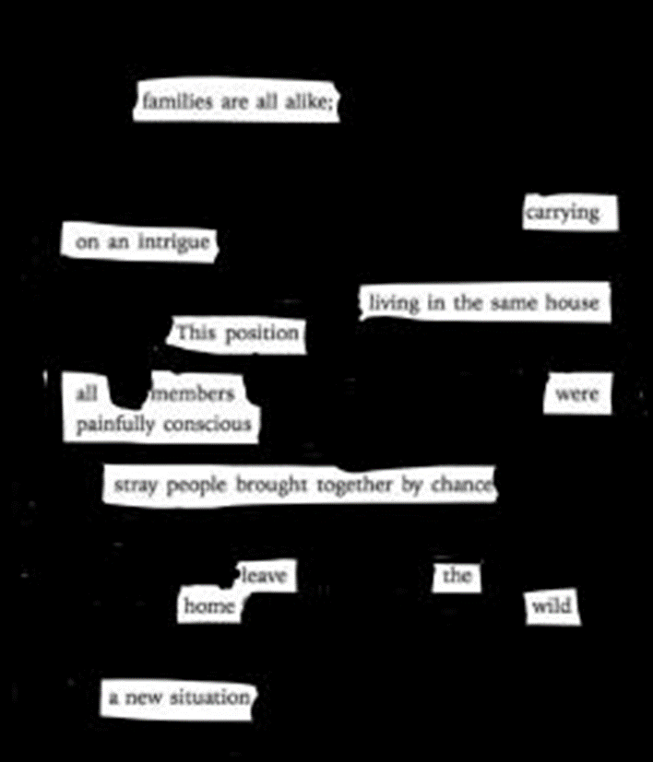
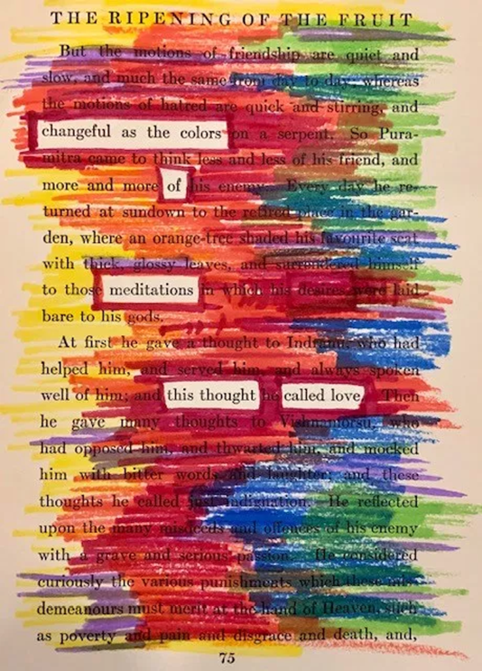

Task:
Read through the extract below. Once you have read through it, use a pencil and go through it picking out key words or phrases that you want to piece together. Rememeber when you read these back they should make a poem that makes sense.
Once you have done this you can begin to create your blackout in any way you want. This does not need to be done in black. You can use colour, draw pictures or stick things around the words if you don’t want to draw!
Once completed you should have a blackout poetry masterpeice.
Marley was dead: to begin with. There is no doubt whatever about that. The register of his burial was signed by the clergyman, the clerk, the undertaker, and the chief mourner. Scrooge signed it. And Scrooge's name was good upon 'Change, for anything he chose to put his hand to.
Old Marley was as dead as a door-nail.
Mind! I don't mean to say that I know, of my own knowledge, what there is particularly dead about a door-nail. I might have been inclined, myself, to regard a coffin-nail as the deadest piece of ironmongery in the trade. But the wisdom of our ancestors is in the simile; and my unhallowed hands shall not disturb it, or the Country's done for. You will therefore permit me to repeat, emphatically, that Marley was as dead as a door-nail.
Scrooge knew he was dead? Of course he did. How could it be otherwise? Scrooge and he were partners for I don't know how many years. Scrooge was his sole executor, his sole administrator, his sole assign, his sole residuary legatee, his sole friend, and sole mourner. And even Scrooge was not so dreadfully cut up by the sad event, but that he was an excellent man of business on the very day of the funeral, and solemnised it with an undoubted bargain. The mention of Marley's funeral brings me back to the point I started from. There is no doubt that Marley was dead. This must be distinctly understood, or nothing wonderful can come of the story I am going to relate. If we were not perfectly convinced that Hamlet's Father died before the play began, there would be nothing more remarkable in his taking a stroll at night, in an easterly wind, upon his own ramparts, than there would be in any other middle-aged gentleman rashly turning out after dark in a breezy spot -- say Saint Paul's Churchyard for instance -- literally to astonish his son's weak mind.
Scrooge never painted out Old Marley's name. There it stood, years afterwards, above the warehouse door: Scrooge and Marley. The firm was known as Scrooge and Marley. Sometimes people new to the business called Scrooge Scrooge, and sometimes Marley, but he answered to both names. It was all the same to him.
Oh! But he was a tight-fisted hand at the grindstone, Scrooge! a squeezing, wrenching, grasping, scraping, clutching, covetous, old sinner! Hard and sharp as flint, from which no steel had ever struck out generous fire; secret, and self-contained, and solitary as an oyster. The cold within him froze his old features, nipped his pointed nose, shrivelled his cheek, stiffened his gait; made his eyes red, his thin lips blue; and spoke out shrewdly in his grating voice. A frosty rime was on his head, and on his eyebrows, and his wiry chin. He carried his own low temperature always about with him; he iced his office in the dogdays; and didn't thaw it one degree at Christmas.
External heat and cold had little influence on Scrooge. No warmth could warm, no wintry weather chill him. No wind that blew was bitterer than he, no falling snow was more intent upon its purpose, no pelting rain less open to entreaty. Foul weather didn't know where to have him. The heaviest rain, and snow, and hail, and sleet, could boast of the advantage over him in only one respect. They often `came down' handsomely, and Scrooge never did.

