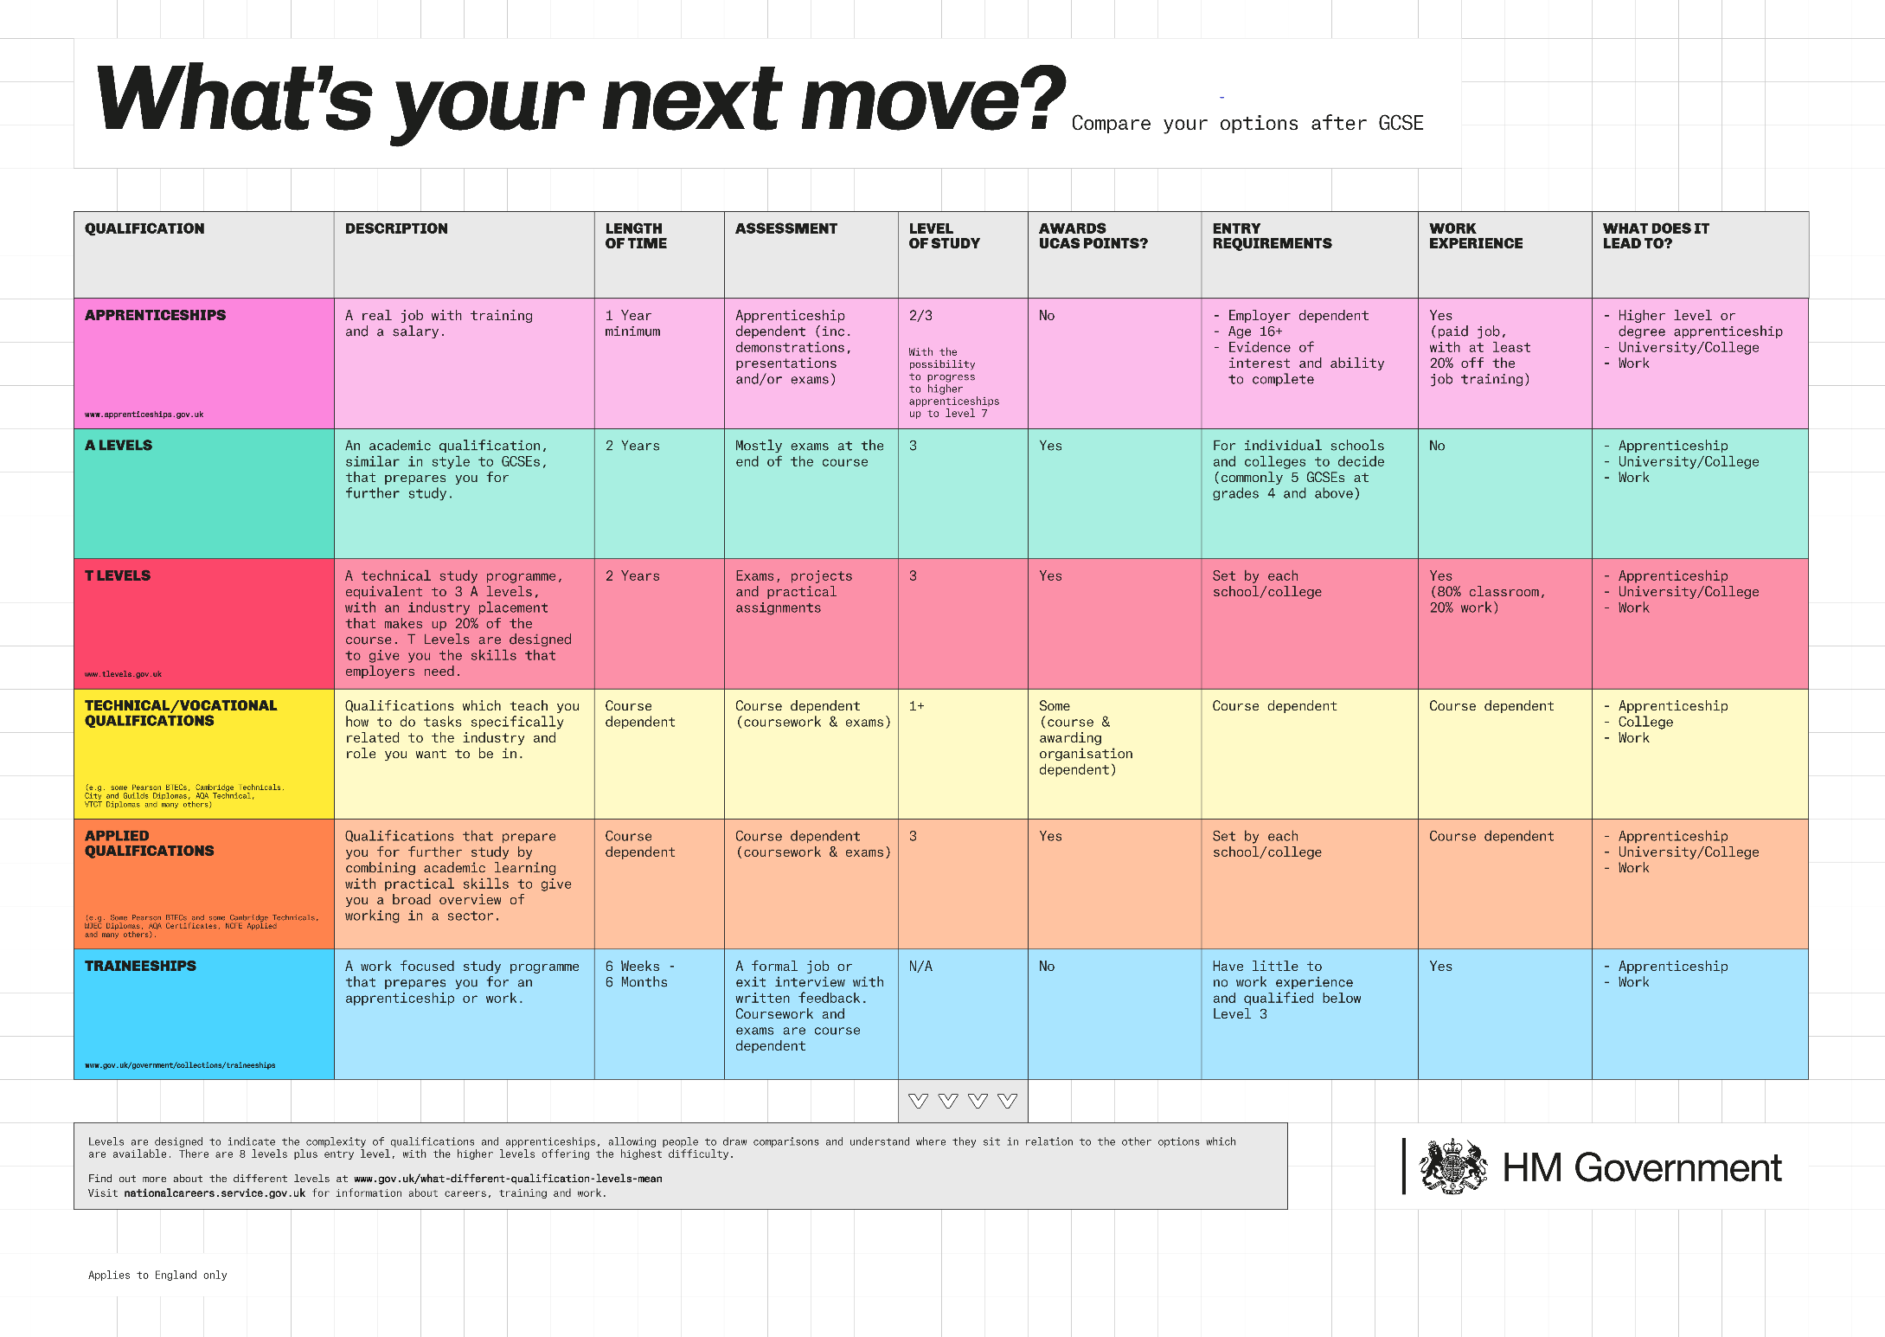
Department for Education Post-16 Choices Animation CLICK ON THE LINK FOR A 2 MINUTE EXPLANATION OF OPTIONS AFTER GCSEs

