Year 6 Welcome to Maths!
Hi everyone,
Here at St Bede’s maths department we are looking forward to meeting you all in the new academic year when you start your new journey in secondary school.
We are a team of five full time maths teachers plus an intervention teacher: Mrs Scott (Curriculum Leader), Mr Gillon (Assistant Curriculum Leader), Mr Swettenham, Miss Caldwell, Mr Doolan and Mrs Hayes (Maths Intervention teacher). We also have some of the science teachers working with us in the department.
Maths is taught in rooms 2, 3, 4, 5 & 6 and each room is equipped with an interactive whiteboard which is used each lesson to show you examples of the work you’ll be doing. We also use mini-whiteboards so you can join in trying to answer the questions or solve the problems as we discuss them together as a class. All your classwork will then be done in your exercise books and kept in class. Don’t forget that in secondary school a lot of the maths we do requires the use of a calculator so you will be expected to bring your own. We recommend this one:
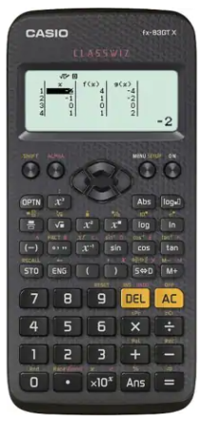

To get you started on some maths, I’ve enclosed some worksheets of varying degrees of difficulty that can get you thinking about maths again. The last task is an investigation you may want to try. You will find that in a lot of our lessons we start off exploring new topics by solving problems and trying to connect the new maths with maths that you already know. If you like doing puzzles, then you can join in with our Friday puzzles which Miss Caldwell puts on our maths Instagram page. You can find us at:

