HUGH BAIRD
Application process | College courses = https://www.hughbaird.ac.uk/apply  A-level courses = https://www.hughbaird.ac.uk/application-alevel  14-16 College = https://www.hughbaird.ac.uk/14-16-college-registration  University Centre = https://www.hughbaird.ac.uk/application-university  Once an application is received you will be contacted by a member of the admissions team to schedule a telephone or video call interview. All of our applications are open until mid-October.  When you have successfully completed your interview, you will be then offered either a conditional or un-conditional offer ready for enrolment in September.
Selection process | The College will always treat each applicant as an individual. Should you not have or not expect to obtain the grades stated above, or not have relevant industry-related experience, the College would still welcome your application for this course as this will enable us to identify whether this course is, in fact, the right course for you or whether another course may be more appropriate.  Equivalent international qualifications would be considered towards general entry criteria.  All course offers will be subject to a satisfactory interview. Completion of additional activities, such as attending Experience Days or gaining a reference, may also be required prior to a place on a course being confirmed.
Course information | 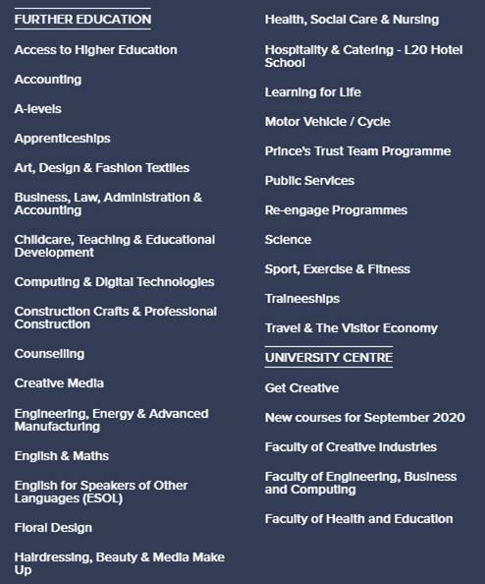
Resources to prepare for Y12 | For anyone who has applied to the College, there will be various communications sent out. Our website features the latest update, so please be advised to check online if you have any further queries. Every subject is different, so preparation can vary.
Further information, guidance and support | https://www.hughbaird.ac.uk/  https://www.youtube.com/results?search_query=hugh+baird+college  Coming to college is big change in your life, whether you’re joining us straight from school or returning to education after a break. There’s so much information to take in, and so many different things to consider. The important thing to remember: don’t worry. We’re here to help and support you through every part of your story – from questions about courses and financial help, to advice on personal issues and future career opportunities. Our friendly and experienced team love helping students like you, every single day. If you’ve got any kind of question, worry or problem – no matter how big or small – you can always talk to them.  Careers and course information, advice and guidance: careers@hughbaird.ac.uk  Safeguarding matters: safeguarding_team@hughbaird.ac.uk  Health and Wellbeing services: janine.hopewell@hughbaird.ac.uk
Information on student finance | Student financial support – including free school meal queries, bursary information, details on bus passes, learner loans: student.finance@hughbaird.ac.uk

LIPA
Application process | This can be found in the “About Us” section of the LIPA Sixth Form College Website in “our policies and procedures section”:  https://www.lipasixthformcollege.org/attachments/download.asp?file=707&type=pdf  https://www.lipasixthformcollege.org/apply
Selection process | Please contact Julie Humphreys at admissions@lipasixthformcollege.org  https://www.lipasixthformcollege.org/page/?title=Admissions&pid=168
Course information | Prospectus  https://www.lipasixthformcollege.org/prospectus
Further information, guidance and support | Useful emails are as follows:  Administration Team: admin@lipasixthformcollege.org  Admissions: LSFCAdmissions@lipasixthformcollege.org  Safeguarding concerns: LSFCSafeguarding@lipasixthformcollege.org  Acting Team: acting@lipasixthformcollege.org  Dance Team: dance@lipasixthformcollege.org  Music Team: musicgroup@lipasixthformcollege.org  Musical Theatre Team: musicaltheatre@lipasixthformcollege.org  Technical Theatre and Design Team: productionarts@lipasixthformcollege.org  English and Maths GCSE Team: LSFCEnglishandMaths@lipasixthformcollege.org  Inclusion Team: inclusion@lipasixthformcollege.org  Careers &Progression: LSFCCareers@lipasixthformcollege.org  Technical Support: technicalsupport@lipasixthformcollege.org
Information on student finance | Will I still be entitled to my Bursary payment?  If you currently receive a termly Bursary from us, you will receive your last Bursary payment no later than 30th April 2020.  Will I still be entitled to Free School Meals?  If you currently receive free school meals from us, funds will be credited to nominated bank accounts by Wednesday 8 April 2020. We wil update you with more information regarding FSM over the summer holidays when we have confirmation and guidance from the government.  https://www.lipasixthformcollege.org/page/?title=Bursaries+%26amp%3B+Free+School+Meals&pid=162

WINSTANLEY
Application process | The application deadline for this year has now passed. However, if a student is interested in putting in a late application, they may be added to our waiting list. Any late applicants just need to get in touch with us via email to admissions@winstanley.ac.uk.
Selection process | The college’s entry policy is 44 points or more from the applicant’s best GCSEs. This averages out to roughly 4 5s and 4 6s. Applicants must complete an informal interview/course discussion prior to being offered a place at the college. All offers are subject to the applicant meeting the minimum points entry in line with our entry policy.
Course information | Information on all of our courses can be found on our website http://www.winstanley.ac.uk/ under the ‘Courses’ tab at the top of the homepage.
Resources to prepare for Y12 | We have bridging resources available for all of our subjects on our website (http://www.winstanley.ac.uk/y11-subject-guides/). These are aimed at year 11 applicants to prepare them to start their year 12 studies in September.
Further information, guidance and support | There is lots of information on our website. If any potential applicants require any further information about the college, have questions or require support - they can email the Admissions team via admissions@winstanley.ac.uk and the query will either be answered by the Admissions team or redirected to the relevant department.
Information on student finance | Any questions regarding student finance can be directed to admissions@winstanley.ac.uk and a member of the Admissions team will direct the query to the relevant department.
How to find the latest information | All of the latest information about the college can be found on our website www.winstanley.ac.uk. We also post regular updates to our social media channels, so applicants are encouraged to follow us on Facebook, Twitter and Instagram.

WIGAN AND LEIGH
Application process | https://www.wigan-leigh.ac.uk/16-18-full-time-courses/apply
Selection process
Course information | https://www.wigan-leigh.ac.uk/16-18-full-time-courses  https://www.wigan-leigh.ac.uk/courses?cat=16-18
Resources to prepare for Y12 | https://www.wigan-leigh.ac.uk/16-18-full-time-courses/new-starters
Further information, guidance and support | https://www.wigan-leigh.ac.uk/about/faqs  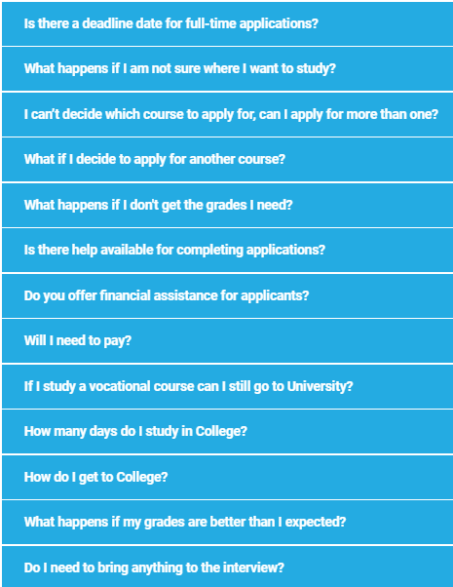
Information on student finance | We have a range of support available for students between 16-18 year old. These include  - College Bursary  - Free College Meals  - Free College Bus  - Free Bus pass  https://www.wigan-leigh.ac.uk/16-18-full-time-courses/student-support/finance-travel-support
How to find the latest information | https://www.wigan-leigh.ac.uk/about/coronavirus-update

ST JOHN RIGBY
Application process | http://sjr.ac.uk/apply_intro.asp  Application form https://apply.sjr.ac.uk/start.php
Selection process
Course information | http://sjr.ac.uk/courses_choosing.asp  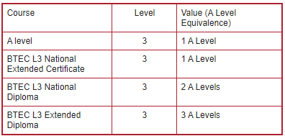
Resources to prepare for Y12 | Virtual New Student Day – Monday 29th June  The VNSD starts at 10:00am and will be repeated again at 2:00pm; on both occasions it will last about an hour and a half.  Links to subjects http://sjr.ac.uk/y11_subject_guides2.asp
Further information, guidance and support | - Year 11 applicants/parents: admissions@sjr.ac.uk  - Staff absences: hr@sjr.ac.uk  - General enquires: enquiries@sjr.ac.uk  ONLY if your enquiry is urgent please call 01942 21479

SOUTHPORT COLLEGE
Application process | Online form  https://www.southport.ac.uk/college16-18/apply
Course information | Our vocational courses use fantastic facilities, industry experienced tutors and valuable work experience to prepare you for University, an Apprenticeship or employment in your chosen career.  https://www.southport.ac.uk/college16-18
Resources to prepare for Y12 | Virtual tour  https://kuula.co/share/collection/ 7lV6b?fs=1&vr=1&sd=1&gyro=0&initload=0&thumbs=1&chromeless= 1&logo=1&logosize=73  Explore  https://www.southport.ac.uk/student-life
Further information, guidance and support | Email  guidance@southport.ac.uk  Call now  01704 392704  Term time  Monday 8.15am – 5pm  Tuesday, Wednesday and Thursday 8.15am- 7.00pm  Friday 8.15am – 5pm  Outside term time  Monday to Thursday 8.30am – 5pm  Friday 8.30am – 4.00pm  Southport College offers a wide range of support to all students, from careers advice & guidance and financial packages to in classroom learning support and personal support, including counselling.
Information on student finance | At Southport College we have a range of financial support packages designed to help meet various costs associated with studying. Suppport can include bursaries, travel passes and help with the costs of kit and uniforms or childcare.  https://www.southport.ac.uk/student-support/college-financial-support
How to find the latest information | Covid updates Y11 specific https://www.southport.ac.uk/schools/year-elevens

KING GEORGE V
Application process | Our admissions team are also still welcoming applications from current year 11 students, and if you need any advice or guidance please do not hesitate to get in touch.  ADMISSIONS@KGV.AC.UK  Online form  https://www.kgv.ac.uk/apply
Course information | A levels  https://www.kgv.ac.uk/a-levels  BTec  https://www.kgv.ac.uk/btec
Resources to prepare for Y12 | Explore here  https://www.kgv.ac.uk/student-life
Further information, guidance and support | Enquiries enquiries@kgv.ac.uk  Admissions admissions@kgv.ac.uk  01704 530601
Information on student finance | At KGV we have a range of financial support packages designed to help meet a range of costs associated with studying.  https://www.kgv.ac.uk/student-support/financial-support

ST HELENS
Application process | Online application  https://www.sthelens.ac.uk/coronavirus/year-11-applicants/changes-to-admissions-process
Course information | https://www.sthelens.ac.uk/prospectuses  Use this filter system to explore  https://www.sthelens.ac.uk/courses
Resources to prepare for Y12 | Activities and resources for Y11 applicants  https://www.sthelens.ac.uk/coronavirus/year-11-applicants/activity-packs  Try some research on Careers Coach  https://sthelens.emsicareercoach.co.uk/
Further information, guidance and support | https://www.sthelens.ac.uk/coronavirus/year-11-applicants
Information on student finance | Should you require help or more information on student finance we have a dedicated Finance Officer who can help you and your students understand financial entitlements and assist with loan applications.

CARMEL
Application process | https://www.carmel.ac.uk/applying/online-application/
Course information | https://www.carmel.ac.uk/  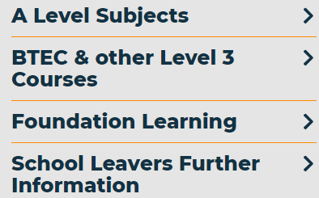
Resources to prepare for Y12 | Virtual Taster Week  https://connect.carmel.ac.uk/course/view.php?id=91
Further information, guidance and support | If you have questions regarding admissions please email admissions@carmel.ac.uk.
Information on student finance | https://www.carmel.ac.uk/challenge-support/financial-support/

Additional information on apprenticeships can be found here too. Be More Apprenticeships was launched by Metro Mayor and pulls in all apprenticeships from all sites.
Website link - https://growthplatform.org/talent/careers-hub/careers-resources/

