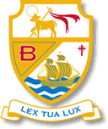
St Bede’s Catholic High School MFL Department - French
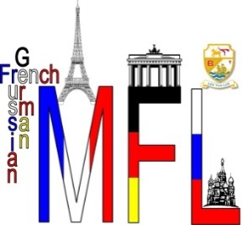
Welcome - bienvenue to the French Department, part of the Modern Foreign Languages Department at St Bede’s!

At St Bede’s we teach French and German. When pupils start with us in Year 7, they get allocated a language and can study the same language right through to Y11. This changes for every Y7 cohort. When you start in September, you will be learning FRENCH.
There are three teachers in the MFL Department: Frau Williams (Curriculum Leader), Madame Gallagher and Madame Williams – yes, two of us are called Mrs Williams! For this reason, one of us ALWAYS uses the German word for Mrs and one of us ALWAYS uses the French word for Mrs. Can you find these words above? It helps you, your parents and pupils and teachers at St Bede’s know the difference!
Some of you may have studied some French before, some of you may not know any. Don’t worry! After a few weeks we will have settled into a nice routine and can help complete beginners and push those of you that already know some French.
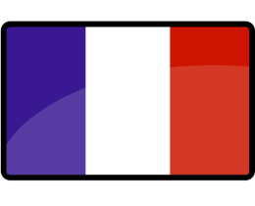
When you start with us, you will have 3x 50 minute lessons of French per week and will cover a variety of exciting topics in Year 7: You, School, Hobbies, Where you live, Meeting up and Holidays!
We’ve put together a few tasks for you to do over the summer so you can start learning some French:
- Make a list of all the things about French you already know: songs, foods, cities, tourist attractions, facts, books, films, actors, fashion, sports and music. If you find you don’t know much about a particular category, do some internet research! Make a separate list of all the French words you already know and as you complete the tasks below, add the new words you have learned!
- Have a good explore of this BBC playlist on YouTube and watch the 10 videos. If you have never really heard French before, it’s a good introduction and each 2/3 minute video covers a different topic. Make notes of the words you hear and practise saying them aloud.
- Did you know French isn’t just spoken in France? Its actually spoken officially in 29 countries around the world! Could you name them all? Could you point to them on a map? Research them and find out! It is the mother tongue of 110 million people and the second language of some 65 million people! French is spoken on every continent. Start a Francophone – ‘’French speaking’ project using the Monopoly board on the next page – you could do it two or three times for different countries!
- Fancy playing some online games? Visit this website and use our log on details username: bede1, password: 9938. You can hear, learn and practise vocabulary in lots of topics!
- Also, you mustn’t forget that learning French isn’t just about learning words, grammar and phrases. We do so many different and interesting activities at St Bede’s which really help us to get to know the culture of the people who speak french all over the world. If you would like to try some cool French crafting and baking activities, log on to this website, there are five different tasks to try!
We cannot wait to meet you and start our language learning journey together as well as hear about all the things you’ve discovered about French over the summer!

À bientôt – see you soon!
