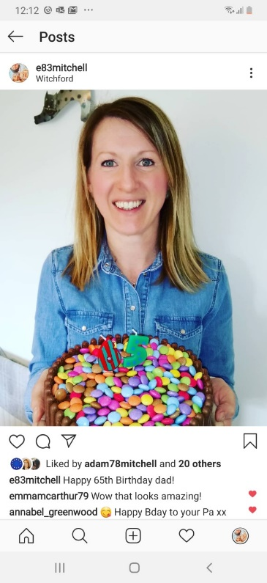

**What you’ll study in Year 7**

**Mrs Morris – Art Technician**

**I have worked at St Bede’s for ten years. In my free time I enjoy anything creative, days out with the family reading and going to music gigs.**

**My favourite piece of art is a textile piece by Naomi Renouf titled Sea and Stones.**

**Miss Byrom – Art Teacher**

**I have worked at St Bede’s for three years. In my free time I enjoy socializing with my friends and family. I love travelling to interesting counties and planning my adventures.**

**My favourite painting is Jenny Saville’s Propped. I love studying the human form and painting portraits.**

**Portraiture**

**In this project you will learn how to draw a self-portrait. You will then learn about four different artists and take on their style using a material sympathetic to their style.**

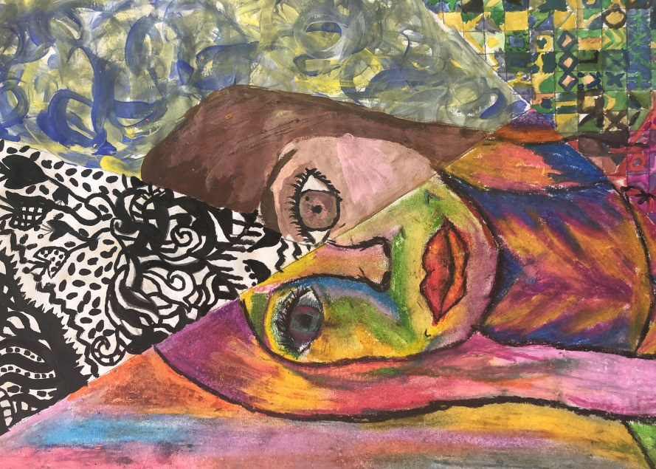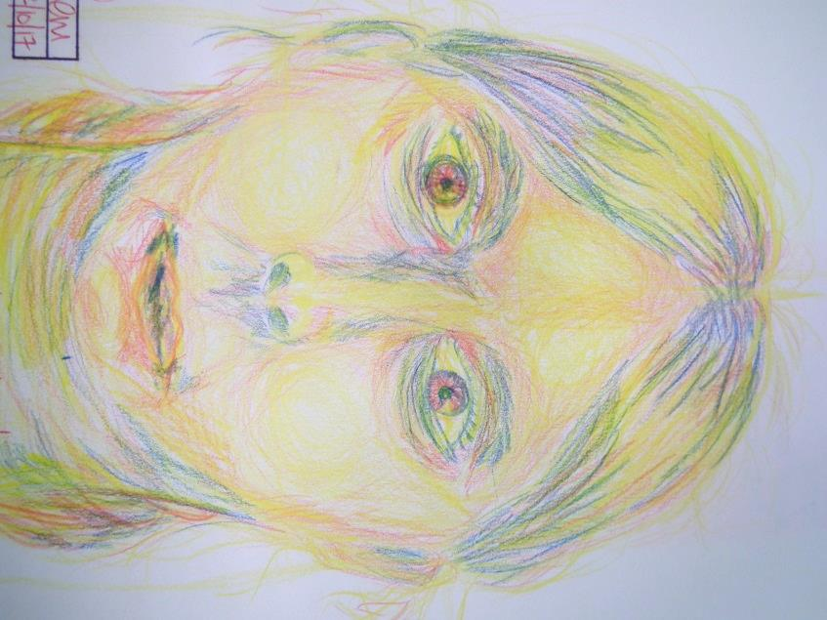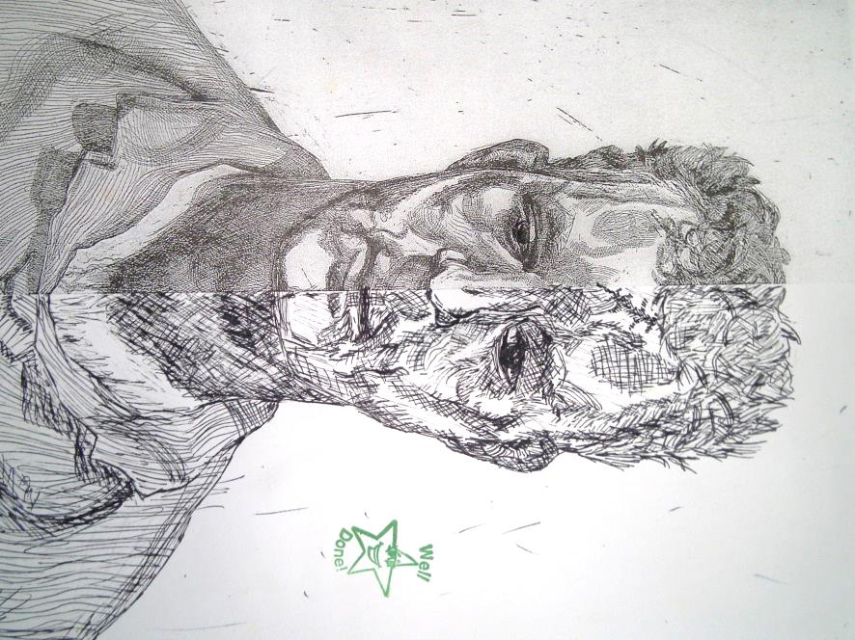

Here are a few examples of work produced by pupils at St Bede’s for this project.

As you can see, we’ve used paint, oil pastel, Indian, ink, watercolour, 2B pencils and colouring pencils.

**Mrs Mitchell – Head of Art**

**I have worked at St Bede’s for 9 years now. In my spare time I enjoy the great outdoors whether it is cycling, running or walking. At home, I enjoy baking and painting with my two children, reading, gardening and listening to the Craig Charles Funk and Soul show.**

**My favorite painting is Picasso’s Weeping Woman.**

**Art & Design**

**St Bede’s Catholic High School**

**Art Challenge**

**Have a go at the challenges on the following page. I’d love to see what you do. Email me at** [**e.mitchell@sbchs.co.uk**](mailto:e.mitchell@sbchs.co.uk)**. I’m looking forward to meeting you…**

**Creative Arts Club**

**During break and lunch times the art room are a hub for budding artists. You can come on up to escape the rain and join in with some creative activities.**

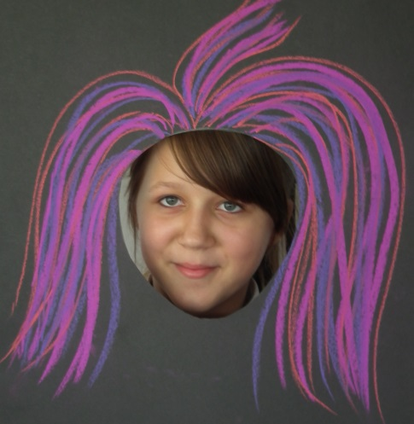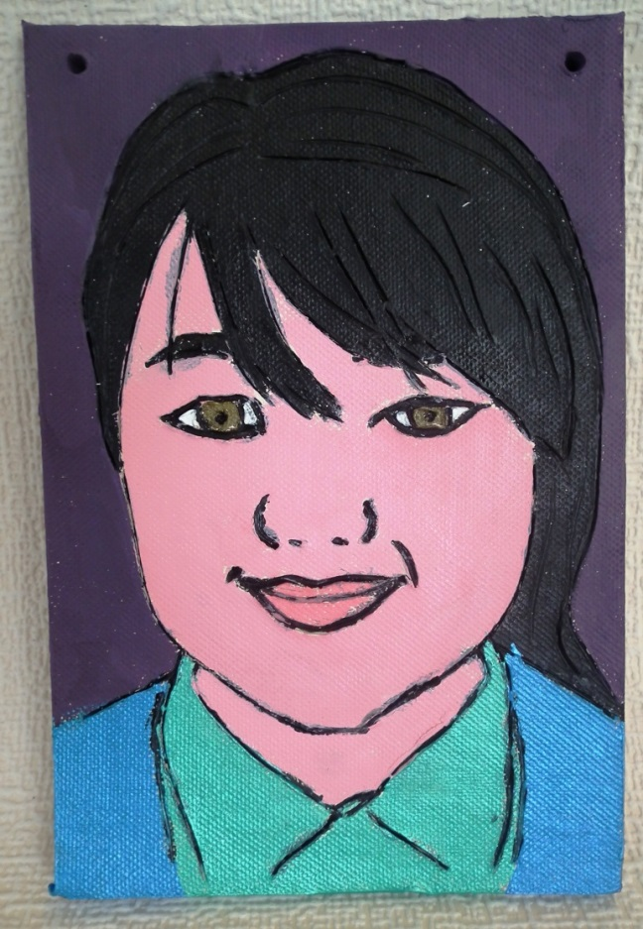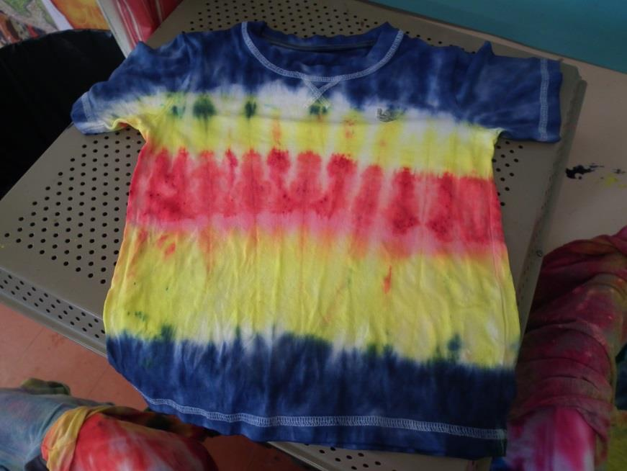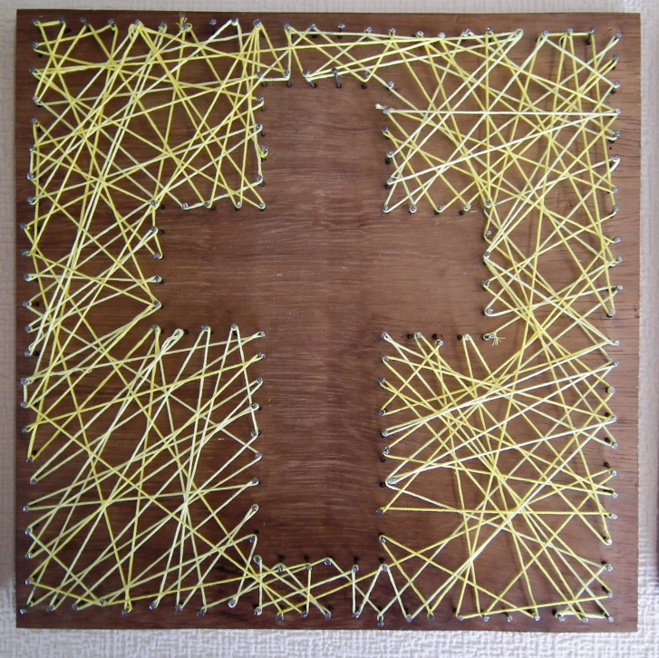

**Into To Drawing**

**In this project you will learn about the artist Fernand Leger. You will have a go at drawing sports figures and turning the bodies into shapes.**

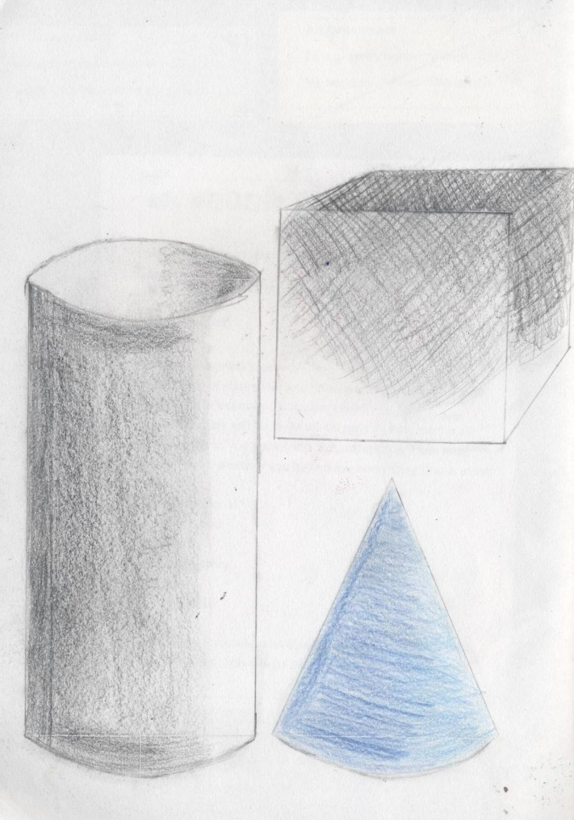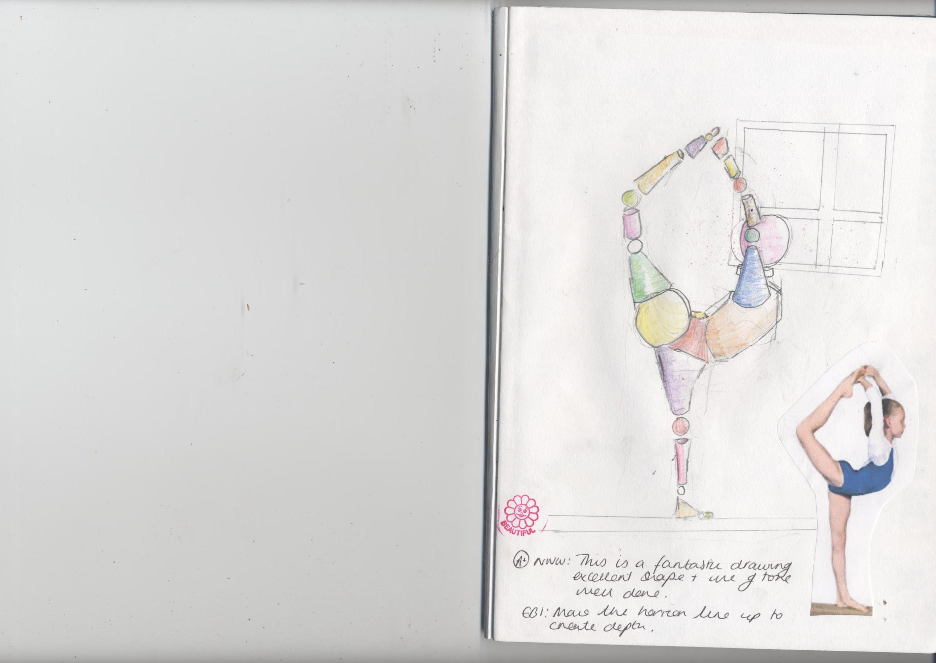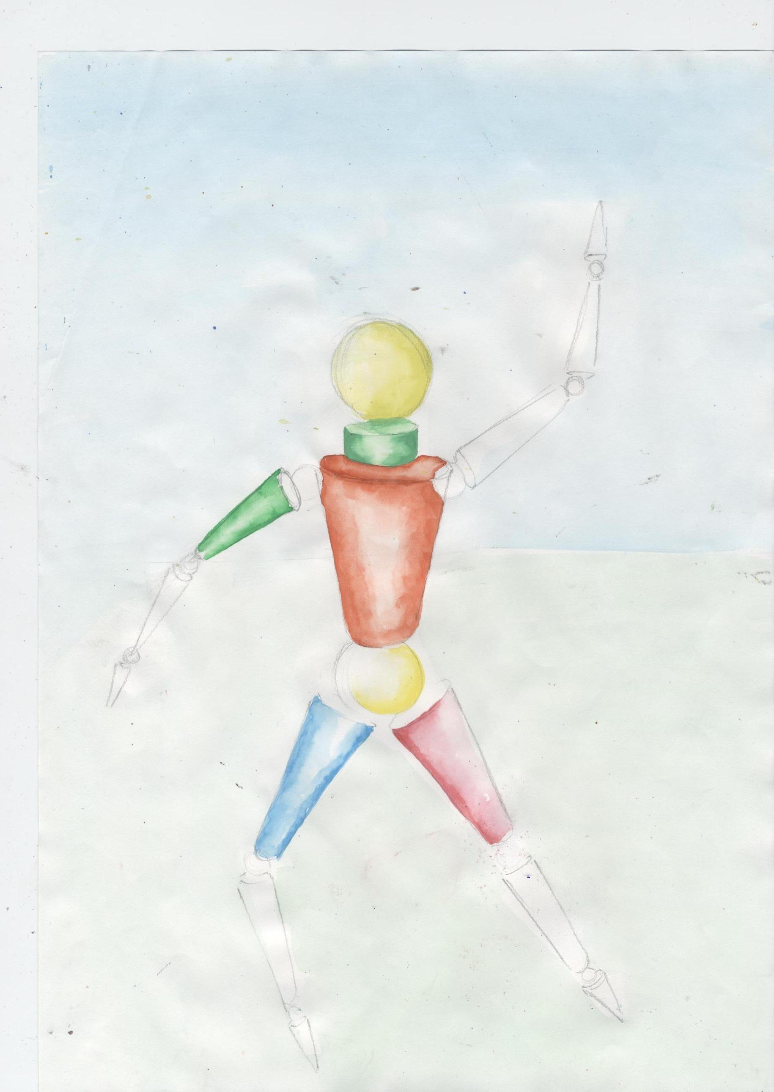**

**Insects**

**In this project you will learn how to draw from observation using a viewfinder to develop a better understanding of composition. You will have a go with Stitching, batik, wax resits and continuous line.**

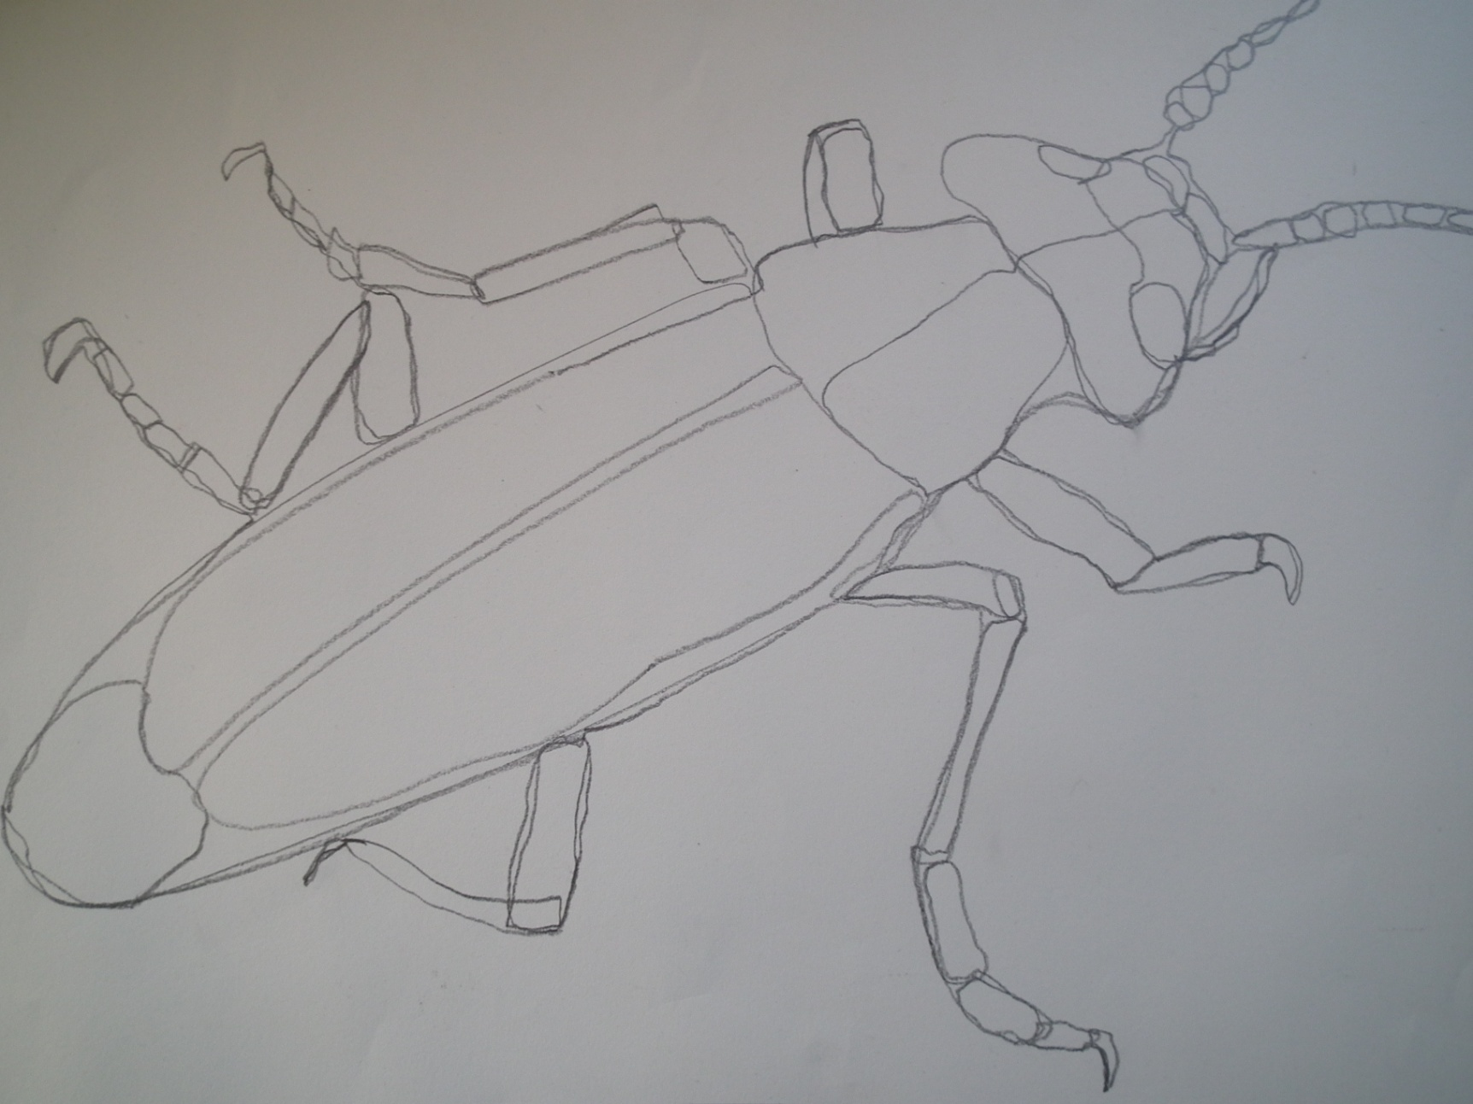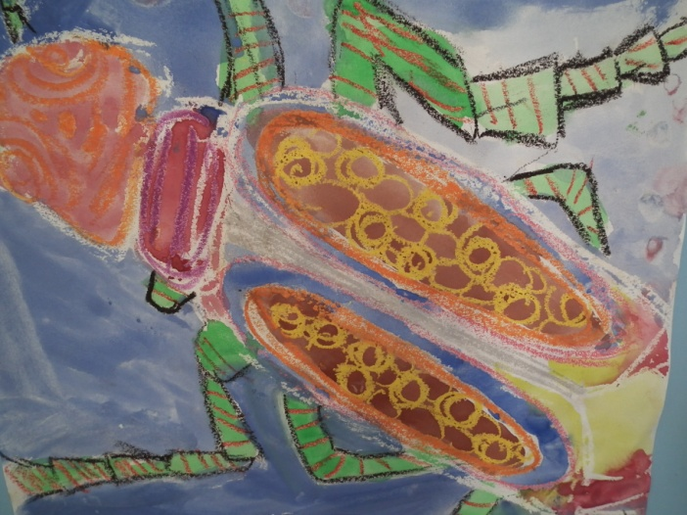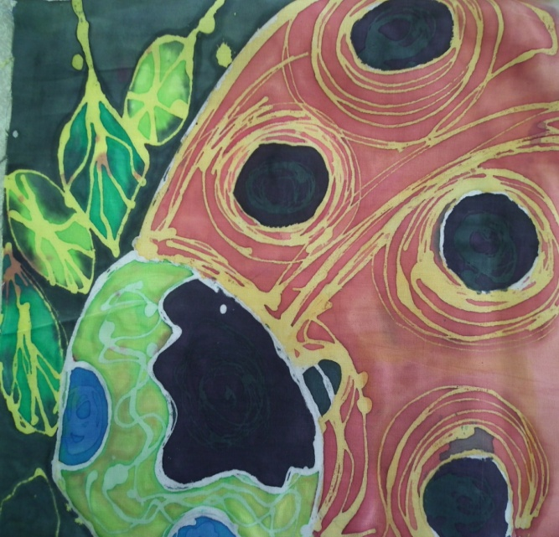

**Art Challenge**

**Become a work of art**

**Dress up as your favourite painting. Here are a few teachers at St Bede’s who took on the challenge.**

**Continuous Line**

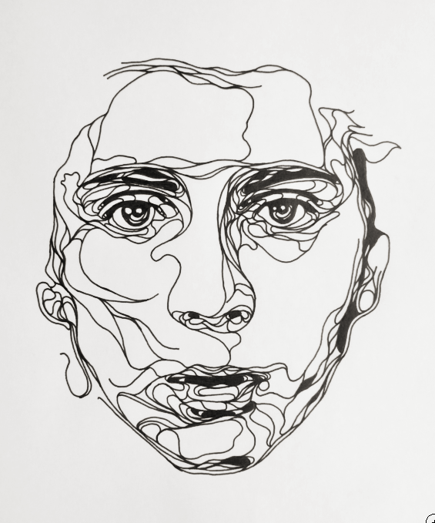

**Ask a member of your family to pose for you. Using a sharp pencil or a black pen, draw their portrait using one continuous line. You cannot take your pencil off the page.**

**Shadow Drawing**

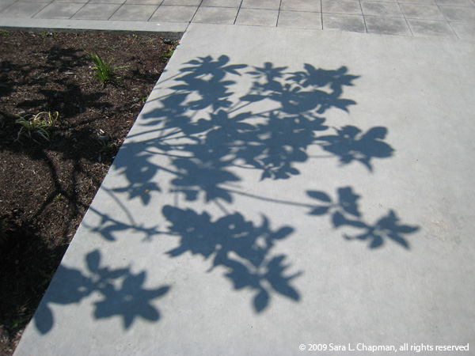

**When the sun is shining, go outside with a piece of paper and a sharp pencil. Put the paper on the floor making sure the shadow is on top of the paper. Draw the shadows that the plants make.**

**Crazy Hair**

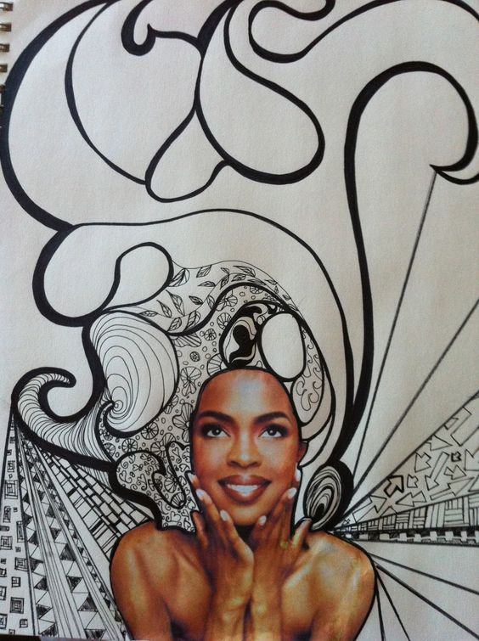

**Cut out a picture from a magazine of a person. Make sure you cut off their hair. Now go crazy with patterns. Use a variety of thicknesses of pens, lines and contrasting patterns.**