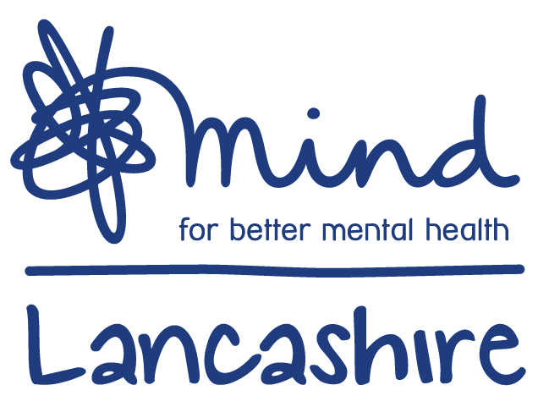
Links & signposting

https://www.mind.org.uk/information-support/coronavirus-and-your-wellbeing/

https://www.mentalhealth.org.uk/publications/looking-after-your-mental-health-during-coronavirus-outbreak

https://youngminds.org.uk/blog/what-to-do-if-you-re-anxious-about-coronavirus/

https://www.studentminds.org.uk/coronavirus.html

https://www.healthyyoungmindslsc.co.uk/information/children-and-young-people

https://www.bbc.co.uk/newsround

https://www.anxietyuk.org.uk/blog/health-and-other-forms-of-anxiety-and-coronavirus/

https://www.mind.org.uk/information-support/for-children-and-young-people/

