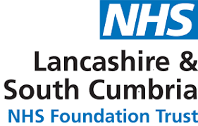

Child and Adolescent Mental Health Services
West Lancashire CAMHS

CAMHS SUPPORT TO CHILDREN,YOUNG PEOPLE AND FAMILIES DURING THE COVID 19 OUTBREAK
Telephone 01695 684262 between 9:00am and 5:00pm Monday-Friday
Weekends 10:00am – 6:00pm
We want to keep you and your families as safe as possible
If you or a member of your household have a high temperature, a sudden cough, or any other symptoms, look on the NHS 111 website to check whether these might be Coronavirus and self-isolate in line with government guidelines
CAMHS appointments
Appointments now will be by telephone or Skype
Children, young people and their parents or carers, would be seen in the clinic ONLY if it is seen as urgent. Please call and discuss this with the person your appointment is with if you are concerned.
Prescription requests CAMHS
Please try giving us 7 working days for repeat prescriptions
Note we are still giving only maximum 30 day prescriptions
We can assure you plans are being made to ensure repeat prescription of medications can be continued, do keep yourself updated through national / local news/media
If you are worried about your own, or someone else’s safety, or if your mental health is making you unwell, please phone us on the number above or ring one of the contact numbers below
Childline: 0800 1111
Wellbeing Mental Health Helpline: 0800 915 4640
Samaritans: 116 123
Domestic Abuse Helpline: 0808 2000 247
Young Minds: Text YM to 85258 for urgent support 24 a day
Kooth: www.kooth.com

